support vector machine(jupyter)

* Using same dataset of Lab03(iris dataset)

[1] I merege trian.txt and test.txt dataset files into third file I name it DataSet.txt

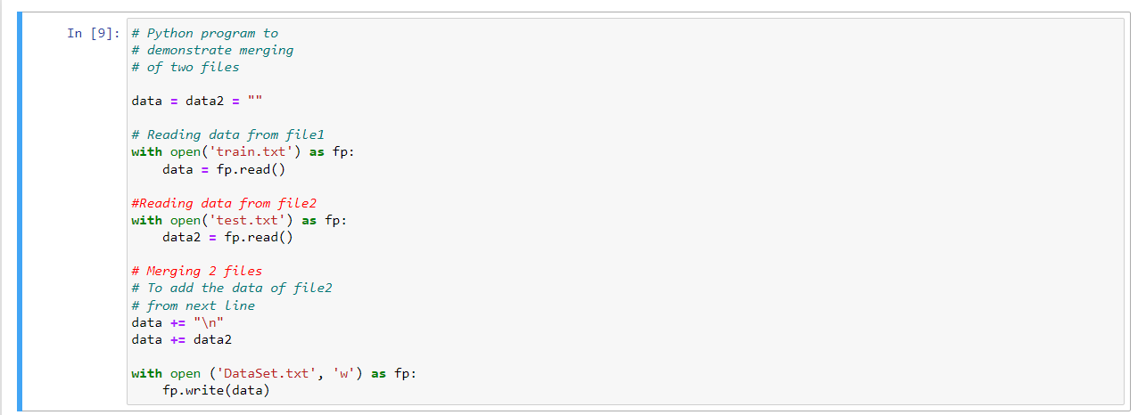

[2] then I git the code parts from github : <https://github.com/ApoorvRusia/SVM-classification-on-Iris-dataset/blob/master/SVM%20classification%20application.ipynb>

&& <https://github.com/AmmirMahdi/Support-Vector-Machine-With-Python/blob/master/SVM%20-%20iris%20DataSet.ipynb>

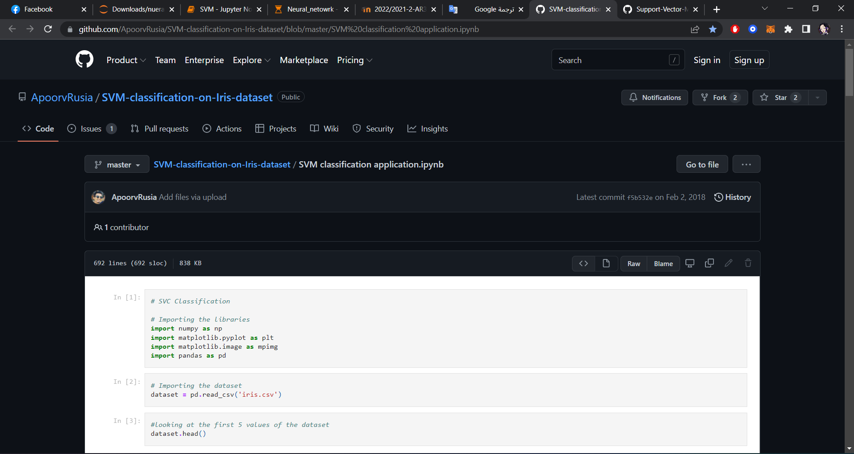

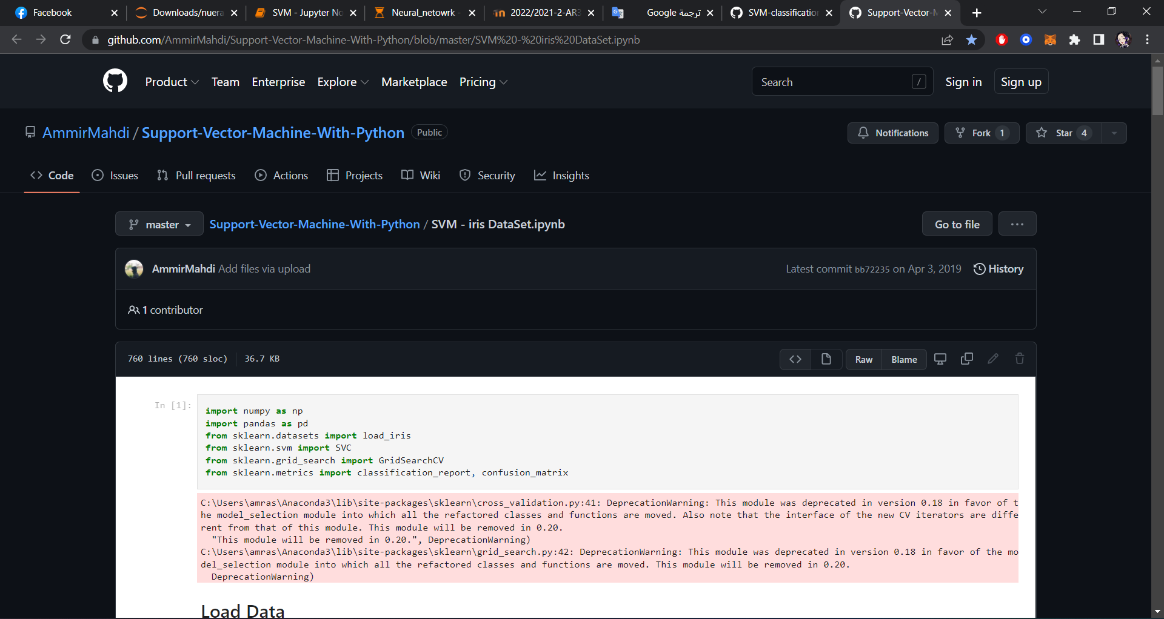

[3] Use different kernal in the same code :

1)Linear Kernel.

2)polynomial kernel.

3)rbf kernel.

4)sigmoid kernel.

[4] test_size = 40 %

[5] Run the code!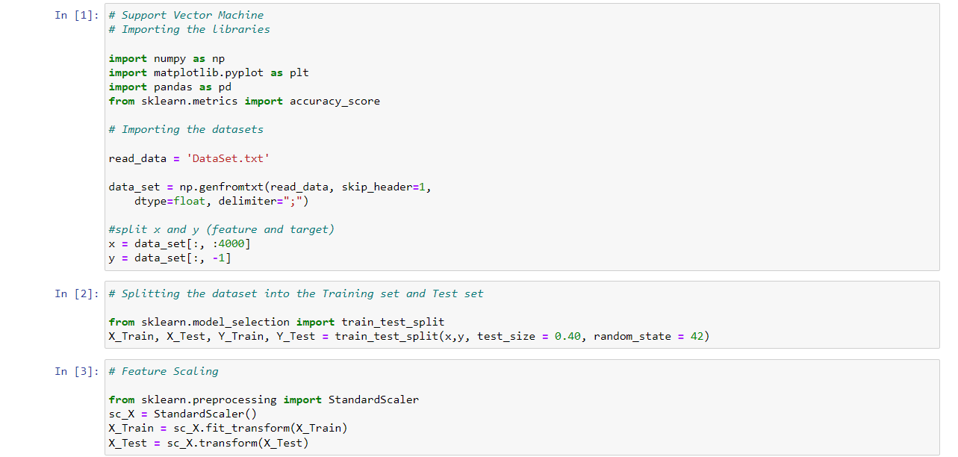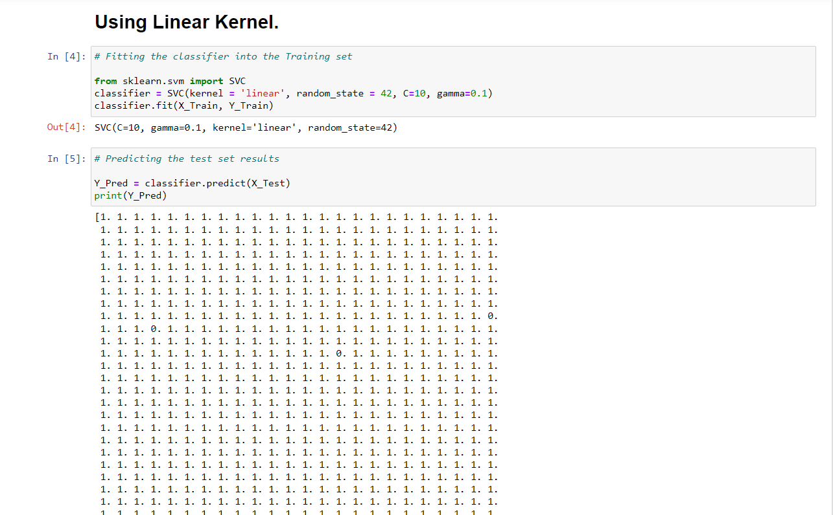

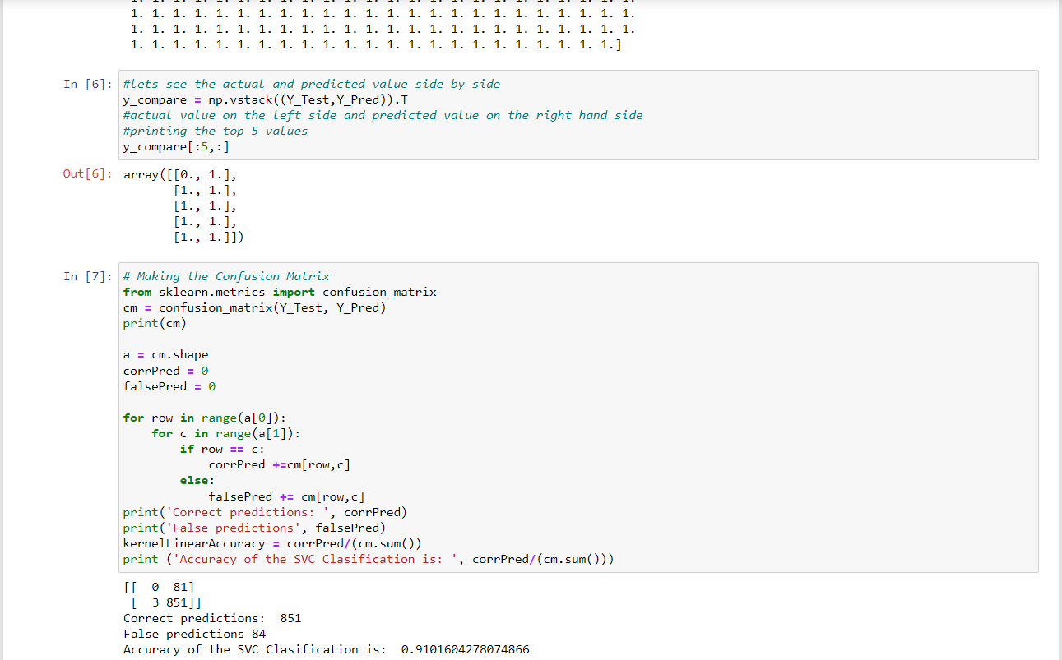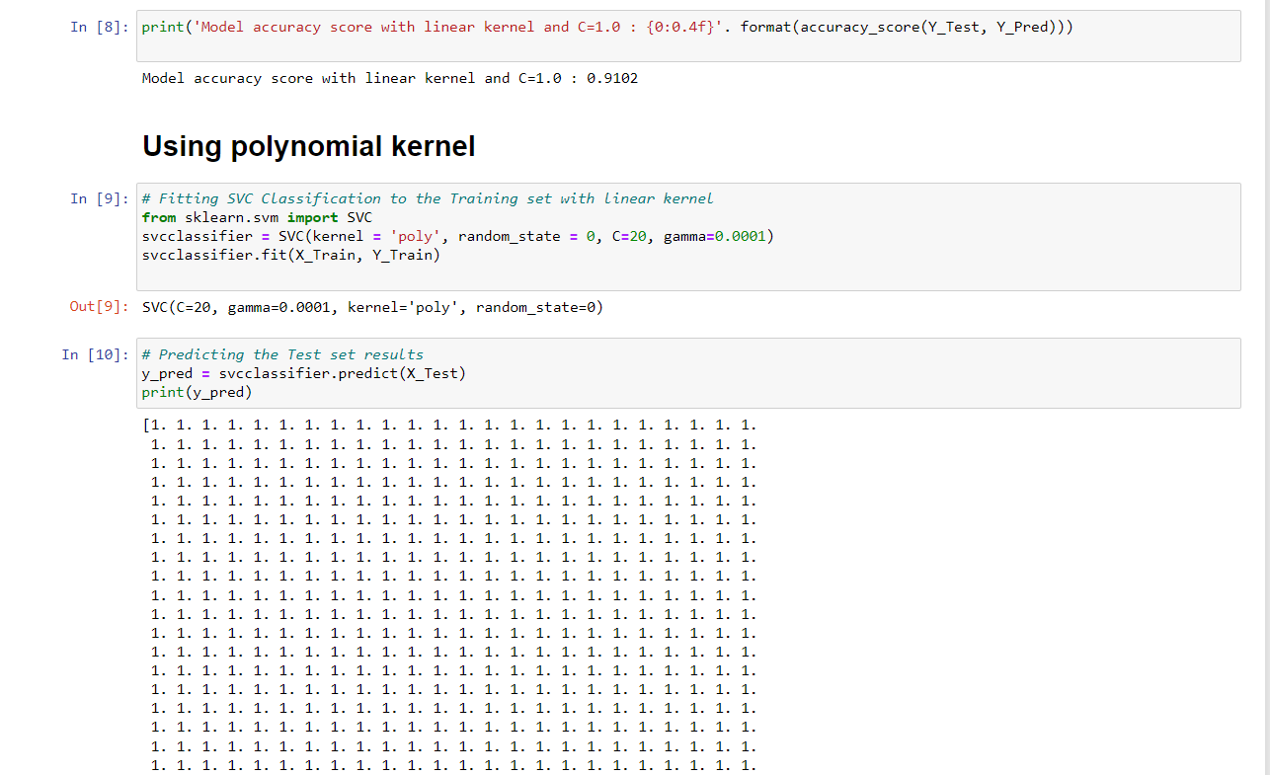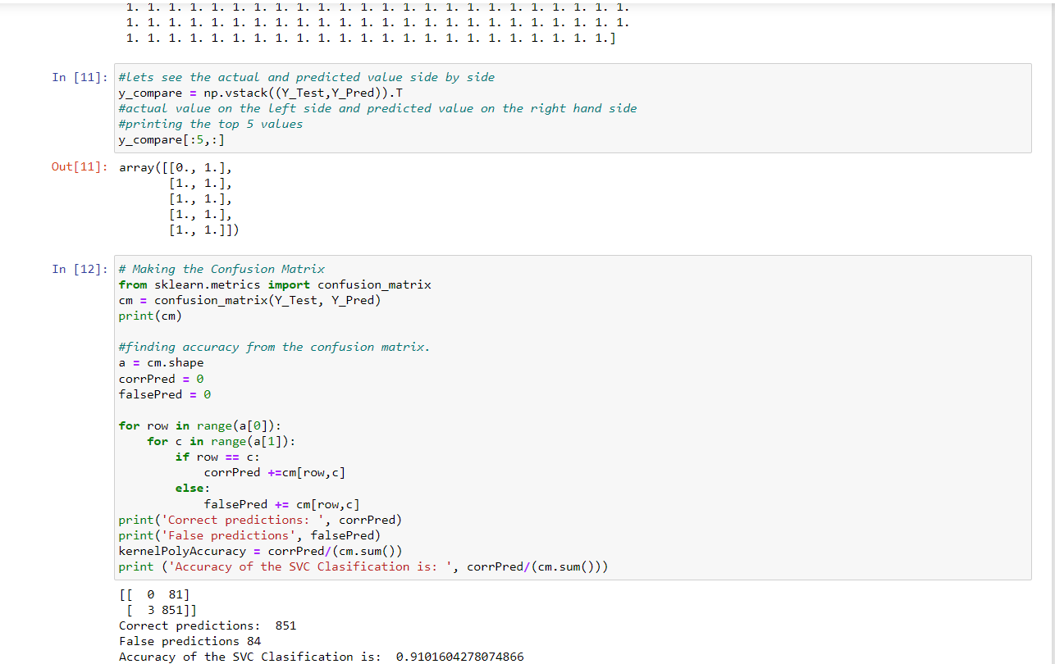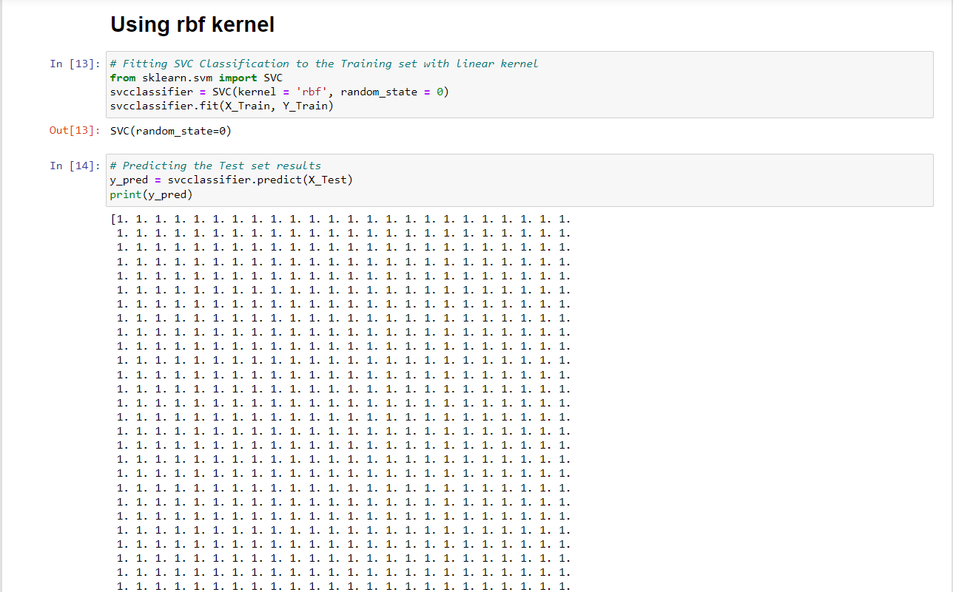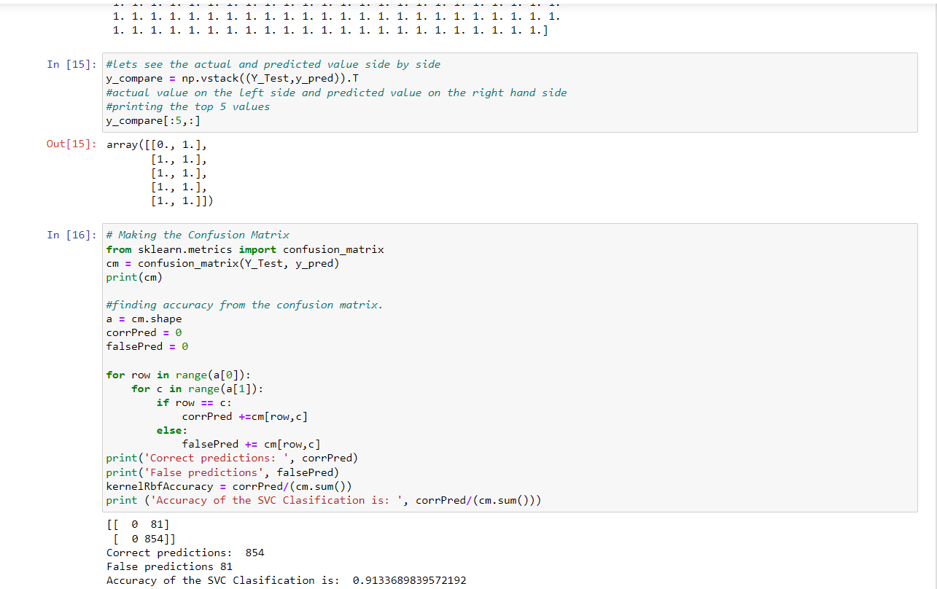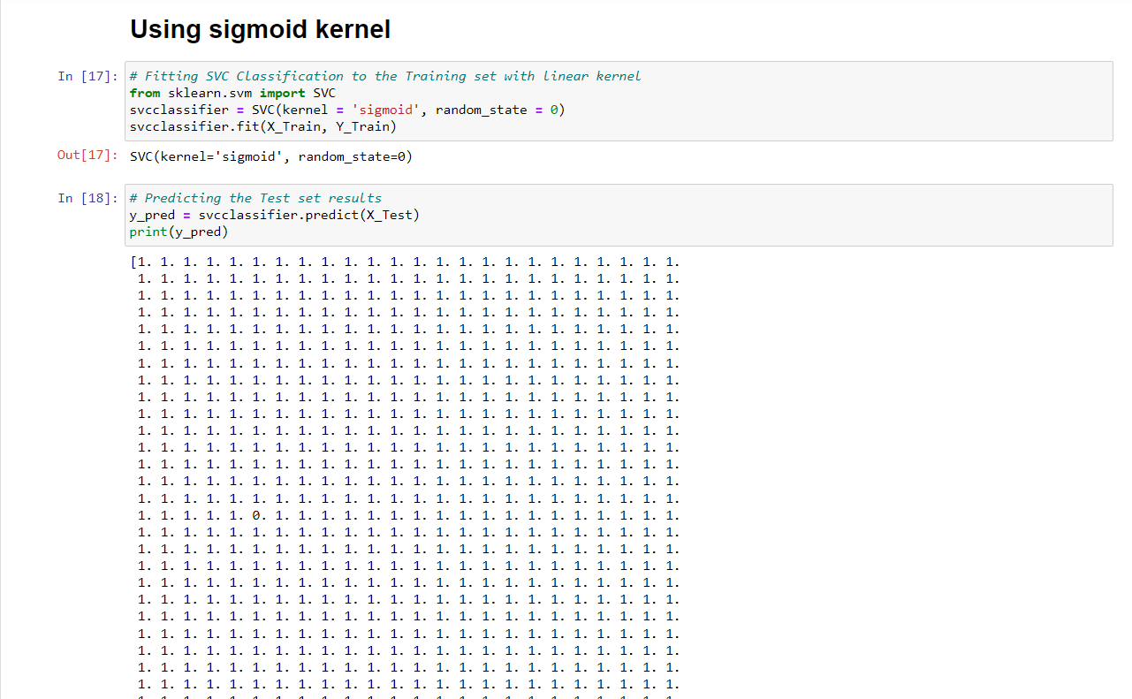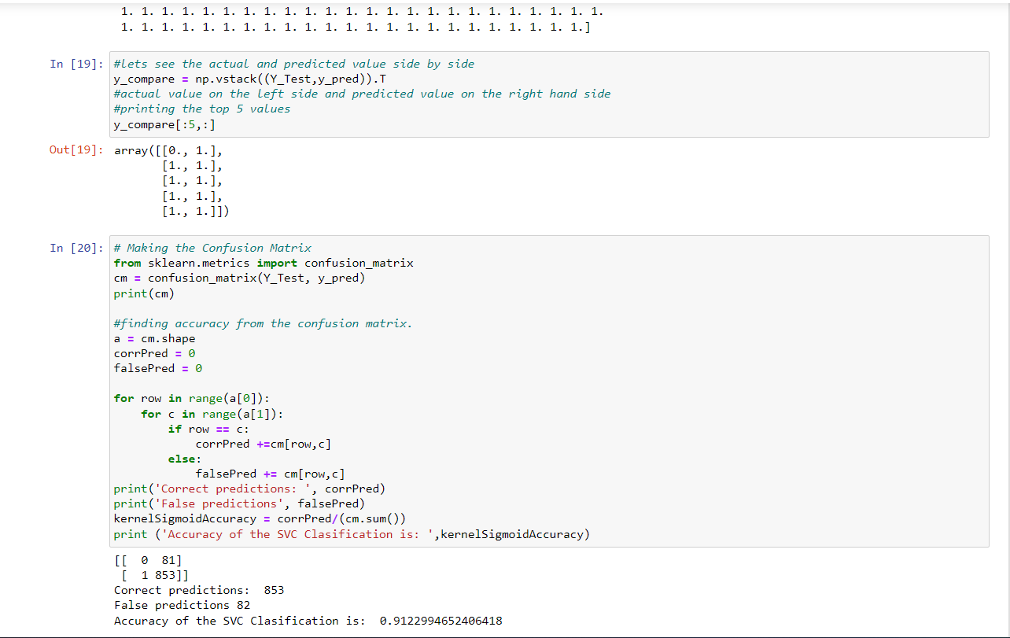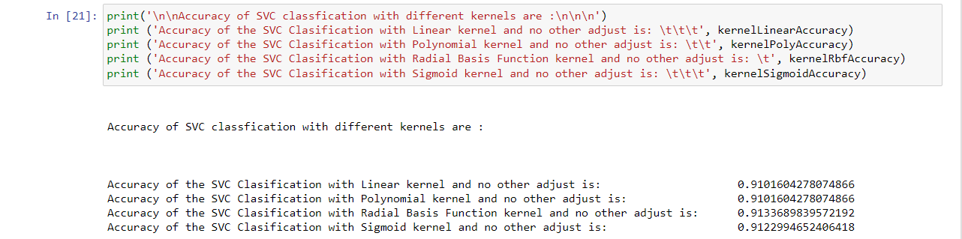

[5] playing with the parameters C & gamma.

# Using Linear Kernel.

SVC(C=1.0, gamma='auto', kernel='linear', random_state=0)

Correct predictions: 524

False predictions: 60

Accuracy of the SVC Clasification is: 0.8972602739726028

**********************************************

SVC(C=10, gamma=0.1, kernel='linear', random_state=0)

Correct predictions: 851

False predictions: 84

Accuracy of the SVC Clasification is: 0.9101604278074866

_ _ _ _ _ _ _ _ _ _ _ _ _ _ _ _ _ _ _ _ _ _ _ _ _ _ _ _ _ _ _ _

# Using polynomial kernel

SVC(kernel='poly', random_state=0)

Correct predictions: 524

False predictions: 60

Accuracy of the SVC Clasification is: 0.8972602739726028

**********************************************

SVC(kernel = 'poly', random_state = 0, C=1, gamma=0.1)

Correct predictions: 851

False predictions: 84

Accuracy of the SVC Clasification is: 0.9101604278074866

_ _ _ _ _ _ _ _ _ _ _ _ _ _ _ _ _ _ _ _ _ _ _ _ _ _ _ _ _ _ _ _

# Using rbf kernel

SVC(kernel = 'rbf', random_state = 0)

Correct predictions: 854

False predictions: 81

Accuracy of the SVC Clasification is: 0.9133689839572192

_ _ _ _ _ _ _ _ _ _ _ _ _ _ _ _ _ _ _ _ _ _ _ _ _ _ _ _ _ _ _ _

# Using sigmoid kernel

SVC(kernel='sigmoid', random_state=0)

Correct predictions: 853

False predictions: 82

Accuracy of the SVC Clasification is: 0.9122994652406418

Accuracy of SVC classfication with different kernels are :>

Accuracy of the SVC Clasification with Linear kernel and no other adjust is: 0.9122994652406418

Accuracy of the SVC Clasification with Polynomial kernel and no other adjust is: 0.9101604278074866

Accuracy of the SVC Clasification with Radial Basis Function kernel and no other adjust is: 0.9133689839572192

Accuracy of the SVC Clasification with Sigmoid kernel and no other adjust is: 0.9122994652406418

​

### Name : Ramah hashem madi.

### ID no. : 31909303044.